EXPLORE THE WORLD WITH SHEAFE’S FLAT BLUEBIRD
Due: Thursday, May 17, 2012
STUDENT NAME: ____________________________________________________ ROOM ___________
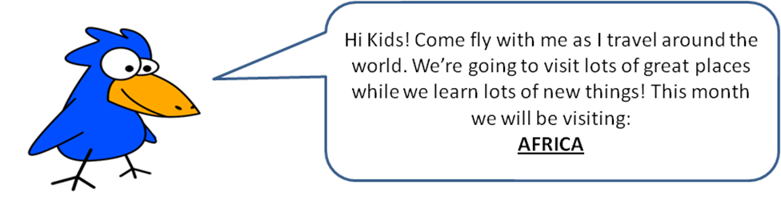
WOW! I have been traveling around the world for a long time. Thank you for following my trip. I hope you have enjoyed learning about the different continents that make up our world. I’m almost ready to come home. I’ll definitely be back at Sheafe Road Elementary School by the time of the Multi-Cultural Fair on Wednesday evening, May 23rd. I hope you’ll be at the Multi-Cultural Fair too. Don’t forget to bring in the yellow slip so we can know how many people to plan for. But, before I start on the flight home, I want to visit one more place. That’s the island of Madagascar. You might have heard of it. Remember there was a Disney movie called Madagascar? Well, Madagascar is an island (remember an island is a body of land completely surrounded by water) off the southeastern coast of Africa. Madagascar is the fourth largest island in the world. About 18 million people live on the island. The people of Madagascar are a mixture of Asian and African, with some people from the Middle East.
Madagascar has two seasons: a rainy season (December – April) and a dry season (May – November). The island experiences severe storms called cyclones. They bring a lot of rain to Madagascar and cause floods.
Madagascar is home to many unusual animals and plants. More than half of the animals on Madagascar do not live anywhere else in the world. The baobab tree is the national symbol of Madagascar. It is also known as the “monkey-bread tree.” It is one of nature’s oldest and oddest trees. It can live for thousands of years. The Baobab tree looks a bit strange. It looks like a bottle, with a very big trunk and a smaller top. (The trunk is large because it is used to store water for the dry season.) The top is not thick. Imagine if a tree was turned upside down and the roots were at the top; that’s what the Baobab tree looks like.
I’m so anxious to get back to Sheafe Road that I’m only giving you one challenge this week. Using the information about the Baobab tree, draw a picture of what you think it looks like.

DON’T FORGET TO COME TO THE MULTI-CULTURAL FAIR ON MAY 23rd. I’LL BE THERE!

